Entry Name:  **TTU-Nhat-MC1**

**VAST Challenge 2019  
Mini-Challenge 1**

**Team Members:**

Nhat Le, IDV Lab, Texas Tech University, [nhat.le@ttu.edu](mailto:nhat.le@ttu.edu) PRIMARY

Tommy Dang, IDV Lab, Texas Tech University, [tommy.dang@ttu.edu](mailto:tommy.dang@ttu.edu)

**Student Team:**  YES

**Tools Used:**

D3.JS, HTML, CSS, JS

**Approximately how many hours were spent working on this submission in total?**

200 HOURS

**May we post your submission in the Visual Analytics Benchmark Repository after VAST Challenge 2019 is complete?** YES

**Video**

<https://github.com/iDataVisualizationLab/VAST19_mc1/tree/master/Video>

**Questions**

**1** – **Emergency responders will base their initial response on the earthquake shake map. Use visual analytics to determine how their response should change based on damage reports from citizens on the ground. How would you prioritize neighborhoods for response? Which parts of the city are hardest hit? Limit your response to 1000 words and 10 images.**

1. Based on the major earthquake shake map, the center of the quake is in North East side of the city. Safe Town and Old Town are two locations closes to the earthquake center and are impacted significantly.

The response should change and prioritize neighborhood based on the number of report and average level of damage for each location.

According to the 6 geospatial graphs of 6 types of damage, responders can observe the event in a selected time range by using brush in the line graph (number of report).

* By clicking on each geo graph, it will show the summary table which contains the number of report and level of damage of each location.
* The table also shows the current project in each location, this will give enough information for responder to prioritize neighborhood for rescue.

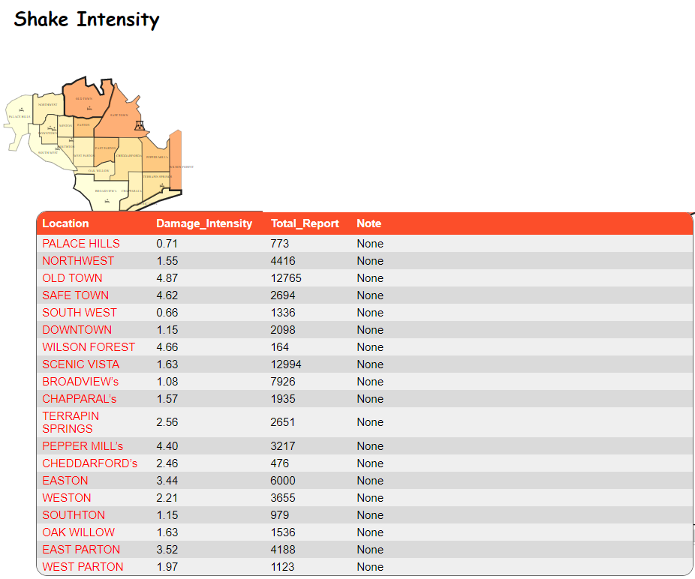

Figure 1 Shake Intensity Average Damage Level

In Figure 1, it shows that OLD TOWN has the highest shake intensity average damage level (4.87) and also very high number of report (12,765), therefore, we can assume that this place is hit very hard by the earthquake. The responder should consider this location for the first priority.

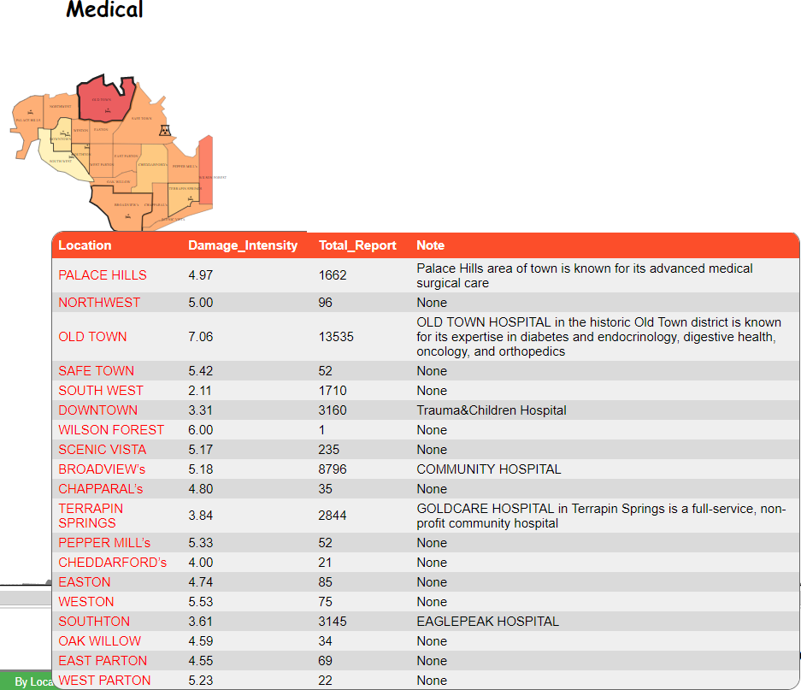

Figure 2 Medical Average Damage Level

In Figure 2, the OLD TOWN and BROADVIEW’s both have high number of report and high average level of damage. Most of the locations which have high number of report and medical damage all

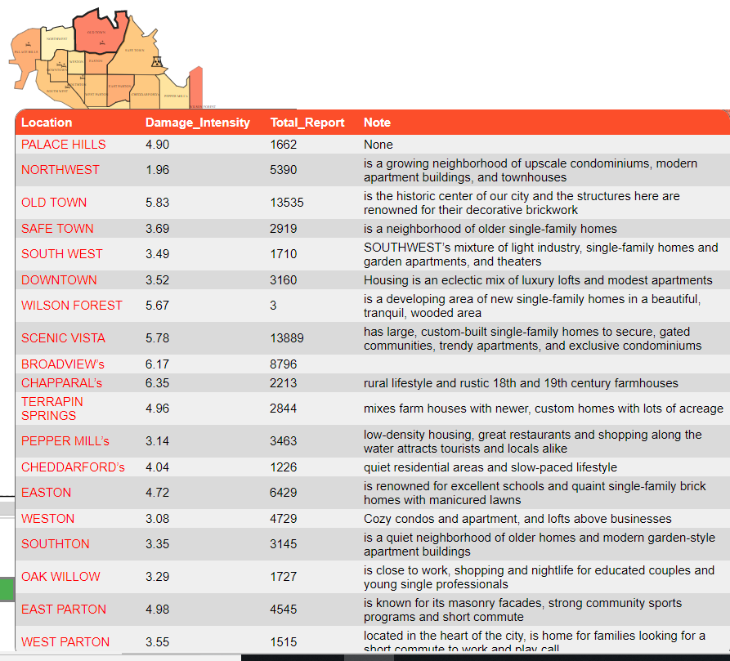

Figure 3 Buildings Average Damage Level

In Figure 3, OLD TOWN, SCENIC VISTA, BROADVIEW should be in the top list of priority to response as for Building Damage.

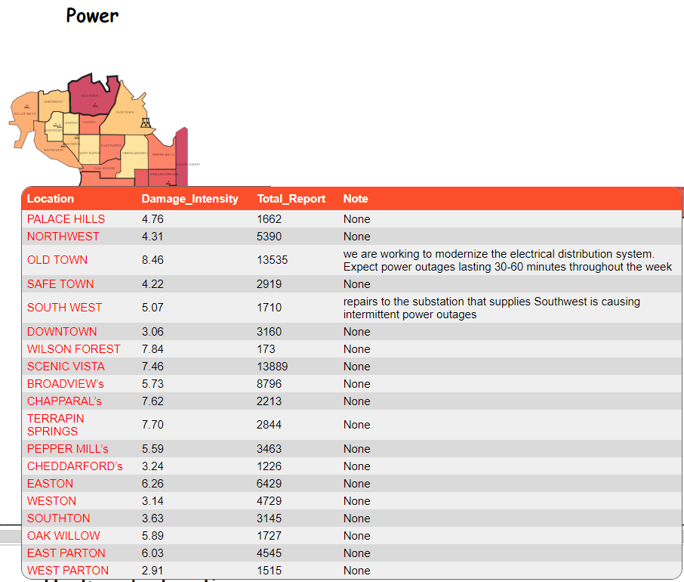

Figure 4 Power Average Damage Level

In Figure 4, the OLD TOWN currently has project related to power and it will expect power outages situation. SCENIC VISTA again has a very high number of report and power average damage level.

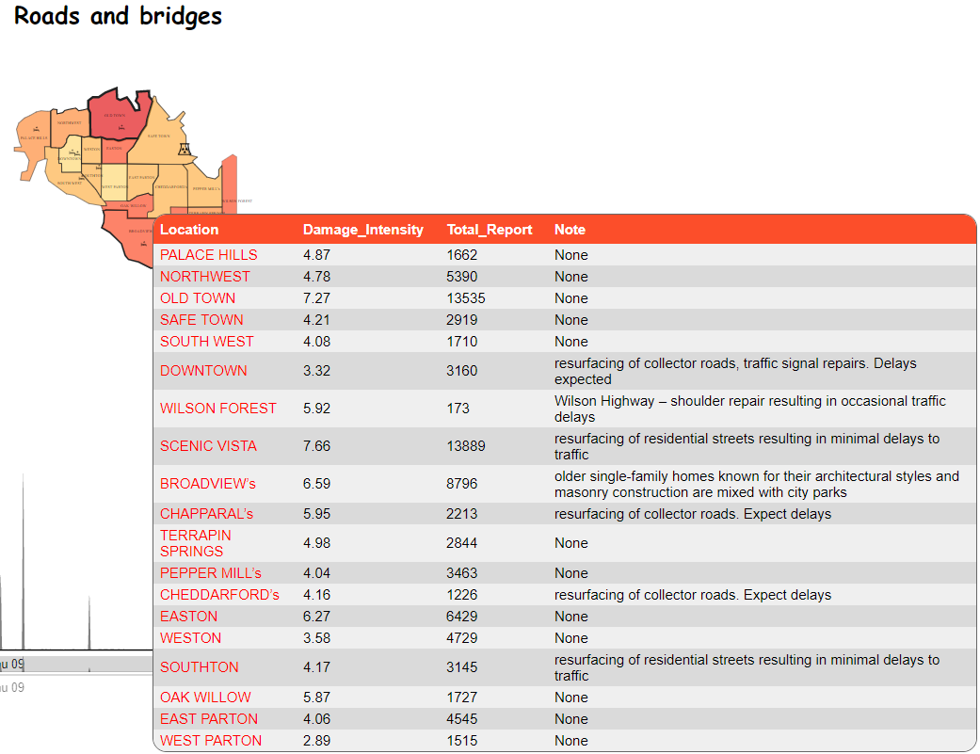

Figure 5 Roads and Bridge Average Damage Level

In Figure 5, the responder should prioritize the location which has current road and bridge project, these projects might be impacted significantly during the earthquake resulting in the high number of report and high level of damage. SCENIC VISTA, BROADVIEW, OLD TOWN are highly damaged.

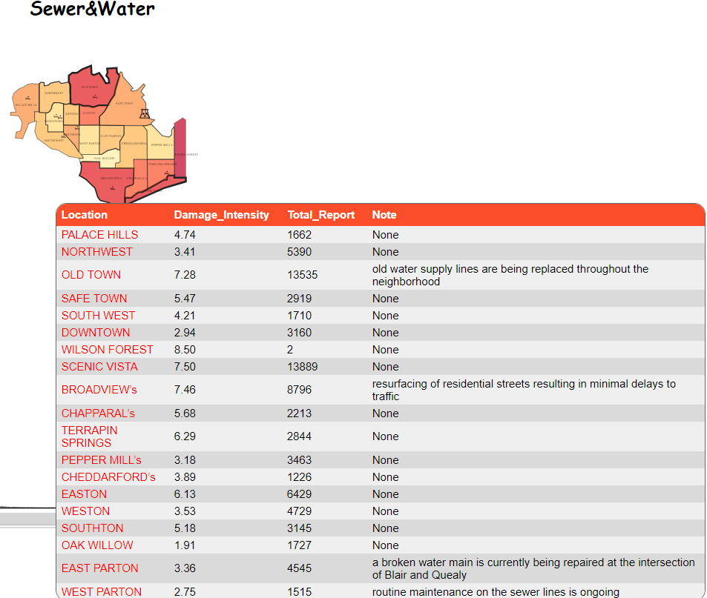

Figure 6 Sewers and Water Average Damage Level

In Figure 6, the responder can prioritize the areas which have current water&sewer projects including OLD TOWN and BROADVIEW, EAST PARTON.

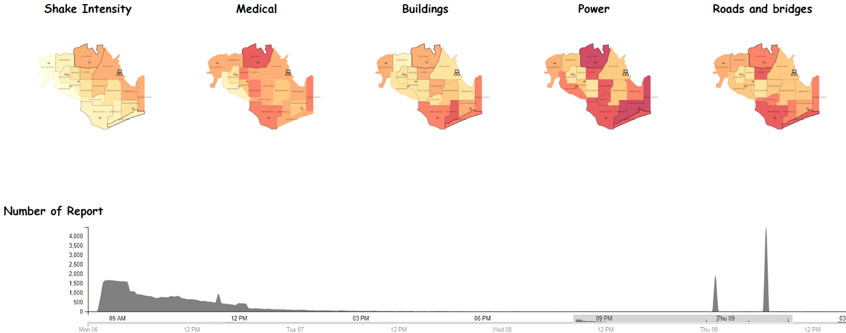

Figure 7 Observe Average Damage Level of All Location in selected time range. (04/08/20 8:20 to 04/09/20 2:50)

1. Old Town is the location which have the second highest number of report (13,535 reports – the 1st highest number of report is Scenic Vista 13,889 reports) and highest average level of damage in Shake intensity, Power and Medical. Furthermore, Old Town also closes to the center of earthquake based on the major-quake shake map. Therefore, we can conclude that Old Town is the hardest hit location.

**2** – **Use visual analytics to show uncertainty in the data. Compare the reliability of neighborhood reports. Which neighborhoods are providing reliable reports? Provide a rationale for your response. Limit your response to 1000 words and 10 images.**

Using the line graph showing standard deviation and quartile 1, quartile 3, median of the event including 6 types of damage of each neighborhood over time, it helps answering the uncertainty questions. The smaller value of standard deviation and the smaller difference between quartile 1 and quartile 3, the more reliable of the report during a specific time range.

In the Figure 1, each neighborhood line graph shows “SD:” (Sample Standard Deviation), the ranking of the Standard Deviation (#1 means the lowest SD value) also mentioned next to the Standard Deviation value. Below the SD value, the number of report and its ranking (#1 means the highest number of report).

**3** – **How do conditions change over time? How does uncertainty in change over time? Describe the key changes you see. Limit your response to 500 words and 8 images.**

**4** –– **The data for this challenge can be analyzed either as a static collection or as a dynamic stream of data, as it would occur in a real emergency. Describe how you analyzed the data - as a static collection or a stream. How do you think this choice affected your analysis? Limit your response to 200 words and 3 images.**